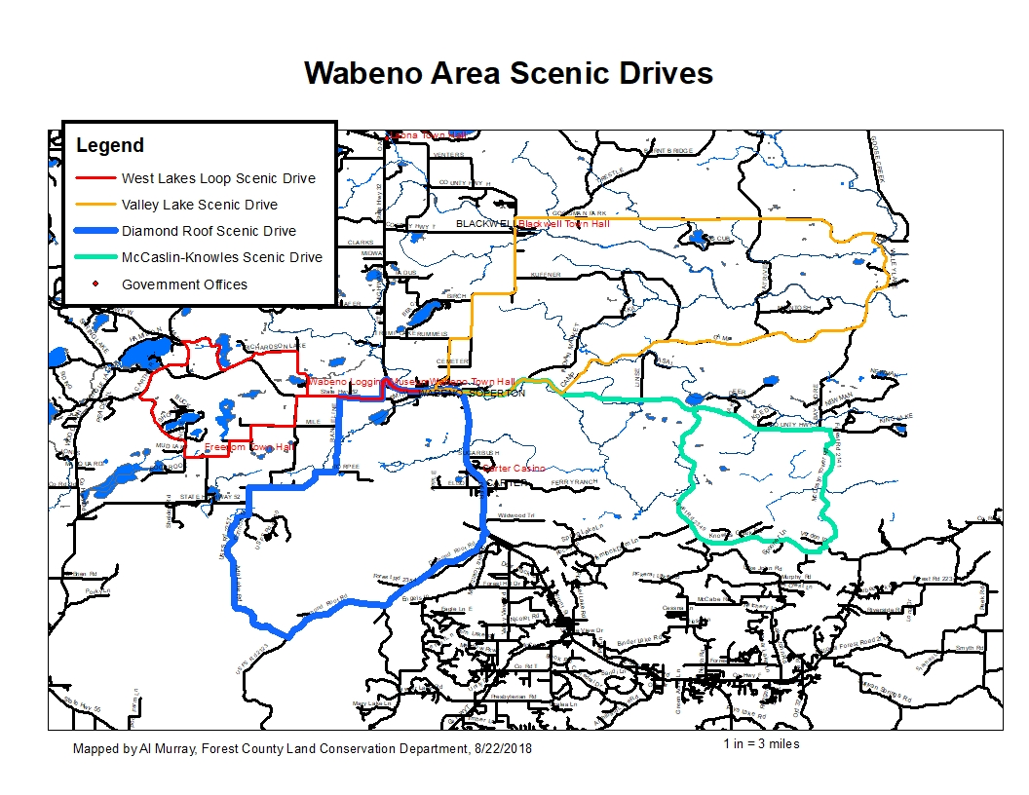

**WABENO- VALLEY LAKE ROAD SCENIC DRIVE DIRECTIONS**

32 miles, Approximately 55 minutes

Google Maps Link:

<https://drive.google.com/open?id=1iWRH6jwWXzVu4jDsOkJFo1k1yOlqsuaV&usp=sharing>

1. Beginning at the Wabeno Logging Museum, 4487 N. Branch Street, Wabeno, WI 54566
2. Head east on WI-32 S toward Hwy H- 0.348 mi
3. Turn Left (north) on Co Hwy H- 5.39 mi
4. stay right on Co Hwy , Slight left to stay on Co Hwy H
5. Turn right (east) Goodman Park Rd- 8.94 mi, 12 minutes
6. Turn right (south) on Valley Lake Rd- 3.58 mi
7. Turn left (northwest) on County C toward Wabeno- 2.75 mi
8. Turn right onto WI-32- 0.961 mi to the beginning

**DISCLAIMER: PORTIONS OF THIS ROUTE IS GRAVEL ROAD AND SHOULD NOT BE TRAVELED IN WET OR INCLEMENT WEATHER, TRAVELER ASSUMES ALL LIABILITY FOR VEHICLE CAPABILITY AND LIMITATIONS**

**WABENO- WEST LAKES SCENIC DRIVE DIRECTIONS**

22 miles, Approximately 41 minutes

Google Maps Link:

<https://drive.google.com/open?id=1iWRH6jwWXzVu4jDsOkJFo1k1yOlqsuaV&usp=sharing>

Head west on WI-32 toward Laona- 0.942 mi

Turn left (west) on WI-52- 3.66 mi

Turn right (west) on Freedom Corners Rd.- 0.998 mi

Turn left to stay on Freedom Corners Rd.- 2.00 mi

At stop sign go straight on McArthur Trail Rd..- 4.87 mi

Turn left on County W.- 0.782 mi

Turn right Himley Lake Rd..- 2.86 mi

Turn left on County W.- 0.682 mi

Turn left on Richardson Lake Rd. stay right at intersection with Gayhart Rd.- 2.91 mi

Turn left (east) on WI-52- 2.42 mi

Turn right (southeast) on WI-32 toward Wabeno- 0.942 mi to the beginning

**DISCLAIMER: PORTIONS OF THIS ROUTE IS GRAVEL ROAD AND SHOULD NOT BE TRAVELED IN WET OR INCLEMENT WEATHER, TRAVELER ASSUMES ALL LIABILITY FOR VEHICLE CAPABILITY AND LIMITATIONS**

**WABENO- MCCASLIN-KNOWLES SCENIC DRIVE DIRECTIONS**

30 miles, Approximately 52 minutes

Google Maps Link:

<https://drive.google.com/open?id=1iWRH6jwWXzVu4jDsOkJFo1k1yOlqsuaV&usp=sharing>

Beginning at the Wabeno Logging Museum, 4487 N. Branch Street, Wabeno, WI 54566

Head east on WI-32 S toward Hwy H- 0.961 mi

Turn left (east) onto County C- 6.06 mi

Turn right (south) on Knowles Creek Rd- 8.16 mi

Turn left (east) on McCaslin Town Rd. (FR 2141)- 4.368 mi

Turn left (west) onto County Rd C- 9.45 mi

Turn right (west) on WI--32- 0.961 mi to the point of beginning

**DISCLAIMER: PORTIONS OF THIS ROUTE IS GRAVEL ROAD AND SHOULD NOT BE TRAVELED IN WET OR INCLEMENT WEATHER, TRAVELER ASSUMES ALL LIABILITY FOR VEHICLE CAPABILITY AND LIMITATIONS**

**WABENO- DIAMOND ROOF SCENIC DRIVE DIRECTIONS**

25 miles, Approximately 44 minutes

Google Maps Link:

<https://drive.google.com/open?id=1iWRH6jwWXzVu4jDsOkJFo1k1yOlqsuaV&usp=sharing>

Beginning at the Wabeno Logging Museum, 4487 N. Branch Street, Wabeno, WI 54566

Head east on WI-32 S toward Carter- 5.73 mi

Turn right (west) onto Diamond Roof Rd.-(FR 2123) 5.65 mi

Turn right (west) on Diamond Roof Rd. (FR - 8.16 mi

Turn right (northwest) on Ada Lake Rd. (FR 2357)- 5.125 mi

Turn left (north) onto Connor Rd. (FR 2620)- .432 mi

Stay straight on WI--52- 0.98 mi to sharp corner, stay straight

Stay straight on Range Line Rd (FR 2358)- 1.68 mi to sharp corner, go left to stay on Range Line

Turn left on Range Line Rd (FR 2653)-. 2.5 mi

Turn right (east) on WI-52 toward Wabeno- 1.68 mi

Turn right (southeast) on WI-32 toward Wabeno- 0.92 mi to the beginning

**DISCLAIMER: PORTIONS OF THIS ROUTE IS GRAVEL ROAD AND SHOULD NOT BE TRAVELED IN WET OR INCLEMENT WEATHER, TRAVELER ASSUMES ALL LIABILITY FOR VEHICLE CAPABILITY**

**AND LIMITATIONS**