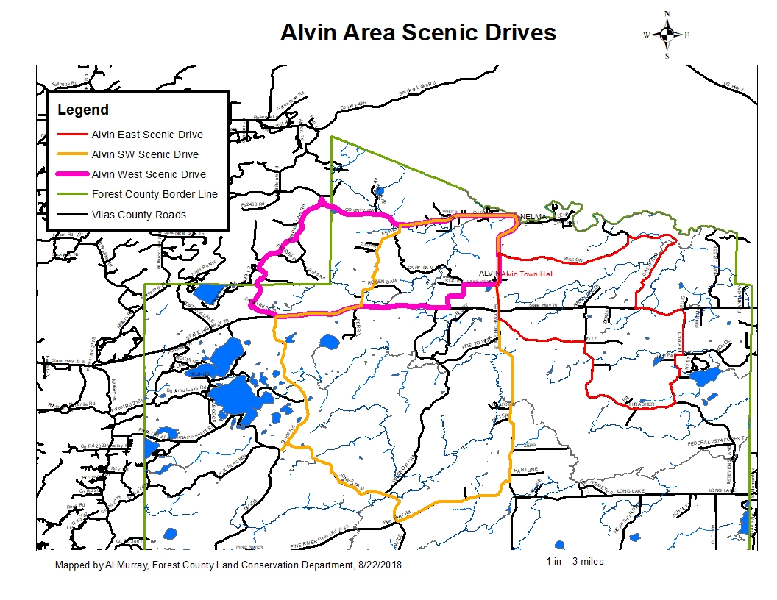

**Alvin West Scenic Drive Directions**

**24 miles, approximately 38 minutes**

Google Maps Link:

<https://drive.google.com/open?id=1dFJcQXFjmmpiBFfB1OUdKSti5VULKWdn&usp=sharing>

1. Starting at the Alvin Town Hall, 16942 State Hwy 55,
2. Head north on State Hwy 55- 2.71 mi
3. Turn left (north) onto County A.- 6.59 mi
4. Turn left (southwest) onto Divide Rd- 1.98 mi
5. Stay slight right (southwest) onto to stay on Divide Rd (FR 2176)- 2.59 mi
6. Turn left (east) onto WI-70- 5.22 mi
7. Turn left (north) onto Carey Dam Rd. (FR 2458) – 1.4 mi
8. Turn right (east) onto Lakeview Rd (FR 2506)- 1.01 mi
9. Turn left (north) onto State Hwy 55- 751 ft. to the beginning

**DISCLAIMER: PORTIONS OF THIS ROUTE IS GRAVEL ROAD AND SHOULD NOT BE TRAVELED IN WET OR INCLEMENT WEATHER, TRAVELER ASSUMES ALL LIABILITY FOR VEHICLE CAPABILITY AND LIMITATIONS**

**Alvin East Scenic Drive Directions**

**27 miles, approximately 1 hour**

Google Maps Link:

<https://drive.google.com/open?id=1dFJcQXFjmmpiBFfB1OUdKSti5VULKWdn&usp=sharing>

1. Starting at the Alvin Town Hall, 16942 State Hwy 55,
2. Head north on State Hwy 55- 1.19 mi
3. Turn right (east) onto Wilson Rd.- 4.58 mi
4. Turn right (southeast) on Gaspardo Rd- 4.93 mi
5. Turn left (east) onto WI-70- 1.55 mi
6. Turn right (south) onto Lily Pad Rd. (FR 2424)- 1.92 mi
7. Turn right (west) onto Thrasher Rd. (FR 2169) – 5.07 mi
8. Turn left (west) onto Holt Rd (FR 2506)- 2.99 mi
9. Turn right (north) onto State Hwy 55)- 1.62 mi to the beginning

**DISCLAIMER: PORTIONS OF THIS ROUTE IS GRAVEL ROAD AND SHOULD NOT BE TRAVELED IN WET OR INCLEMENT WEATHER, TRAVELER ASSUMES ALL LIABILITY FOR VEHICLE CAPABILITY AND LIMITATIONS**

**Alvin Southwest Scenic Drive Directions**

**38 miles, approximately 1 hour 6 minutes**

Google Maps Link:

<https://drive.google.com/open?id=1dFJcQXFjmmpiBFfB1OUdKSti5VULKWdn&usp=sharing>

1. Starting at the Alvin Town Hall, 16942 State Hwy 55,
2. Head south on State Hwy 55- 8.76 mi
3. Turn right (west) onto Pine River Rd. (FR 2182).- 4.06 mi
4. Turn right (northwest) onto Divide Rd. (FR2177)- 1.44 mi
5. Turn right (north) onto Divide Rd.(FR2176)- 6.03 mi
6. Turn right (east) onto onto WI-70- 2.63 mi
7. Turn left (northwest) onto Fishel Rd (FR 2193)- 4.12 mi
8. Turn right (east) onto County A.- 3.79 mi
9. Turn right (south) onto State Hwy 55- 2.71 mi. to the beginning

**DISCLAIMER: PORTIONS OF THIS ROUTE IS GRAVEL ROAD AND SHOULD NOT BE TRAVELED IN WET OR INCLEMENT WEATHER, TRAVELER ASSUMES ALL LIABILITY FOR VEHICLE CAPABILITY AND LIMITATIONS**