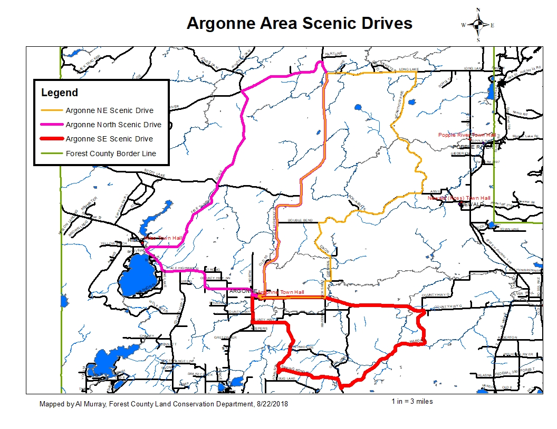

**Argonne North Scenic Drive Directions**

**38 miles, approximately 1 hour, 11 minutes**

Google Maps Link:

<https://drive.google.com/open?id=1YvFmHtLRn1tDEMnsDbEc_dnpKLud_2E0&usp=sharing>

1. Starting at the Argonne Town Hall, 8824 Vanzile St. Argonne,WI 54511
2. Head east on Vanzile St- 118 ft.
3. Turn left (north) onto Pine St.- 367 ft.
4. Turn right (east) onto WI-55- - 15.6 mi
5. Turn left (west) onto Pine River Rd.(FR 2182)- 4.06 mi
6. Turn right (southeast) onto Divide Rd. (FR 2174)- 5.92mi
7. Go straight (southwest) onto Firetower Rd. – 5.39 mi
8. Turn left (southeast) onto WI-32.- 6.32 mi
9. Turn leftt (east) onto WI-55- 745 ft
10. Turn right (south) onto Vanzile St. 780 ft to the benginning

**DISCLAIMER: PORTIONS OF THIS ROUTE IS GRAVEL ROAD AND SHOULD NOT BE TRAVELED IN WET OR INCLEMENT WEATHER, TRAVELER ASSUMES ALL LIABILITY FOR VEHICLE CAPABILITY AND LIMITATIONS**

**Argonne Southeast Scenic Drive Directions**

**27 miles, approximately 1 hour**

Google Maps Link:

<https://drive.google.com/open?id=1YvFmHtLRn1tDEMnsDbEc_dnpKLud_2E0&usp=sharing>

1. Starting at the Argonne Town Hall, 8824 Vanzile St. Argonne,WI 54511
2. Head east on Vanzile St- 495 ft.
3. Turn right (south) onto Main St.- 571 ft.
4. Turn left (east) onto County G- 6.95 mi
5. Turn right (south) onto Margies Rd.(FR 2379)- 7.09 mi
6. Turn right (north) onto Otter Creek Rd.- 0.624 mi
7. Turn left (west) onto Spring Pond Rd. – 2.69 mi
8. Turn right (north) onto Johnson Rd – 3.6 mi
9. Stay straight (west) onto County PO- 1.02 mi
10. Turn right (north) onto WI-32/WI-55- 1.61 mi
11. Turn right (east) onto WI-55- 745 ft
12. Turn right (south) onto Vanzile St. 780 ft to the benginning

**DISCLAIMER: PORTIONS OF THIS ROUTE IS GRAVEL ROAD AND SHOULD NOT BE TRAVELED IN WET OR INCLEMENT WEATHER, TRAVELER ASSUMES ALL LIABILITY FOR VEHICLE CAPABILITY AND LIMITATIONS**

**Argonne Northeast Scenic Drive Directions**

**41 miles, approximately 1 hour, 18 minutes**

Google Maps Link:

<https://drive.google.com/open?id=1YvFmHtLRn1tDEMnsDbEc_dnpKLud_2E0&usp=sharing>

1. Starting at the Argonne Town Hall, 8824 Vanzile St. Argonne,WI 54511
2. Head east on Vanzile St- 118 ft.
3. Turn left (north) onto Pine St.- 367 ft.
4. Turn right (east) onto WI-55- - 14.9 mi
5. Turn right (east) onto Long Lake Rd.(FR 2168)- 3.77 mi
6. Turn right (south) onto MacArthure Pine Rd.(FR 2167)- 8.60 mi
7. Turn right (west) onto Double Bend Rd. – 5.67 mi
8. Turn left (south) onto Dixon Rd – 2.31 mi
9. Turn right (west) onto Cardinal Rd.- 1.48 mi
10. Turn right (west) onto Dick Samz Rd.- 1.24 mi
11. Turn right (west) onto County G- 2.67 mi.
12. Turn right (north) onto Main St. 571 ft to second cross street
13. Turn left (west) onto Vanzile St. 495 ft to the beginning

**DISCLAIMER: PORTIONS OF THIS ROUTE IS GRAVEL ROAD AND SHOULD NOT BE TRAVELED IN WET OR INCLEMENT WEATHER, TRAVELER ASSUMES ALL LIABILITY FOR VEHICLE CAPABILITY AND LIMITATIONS**