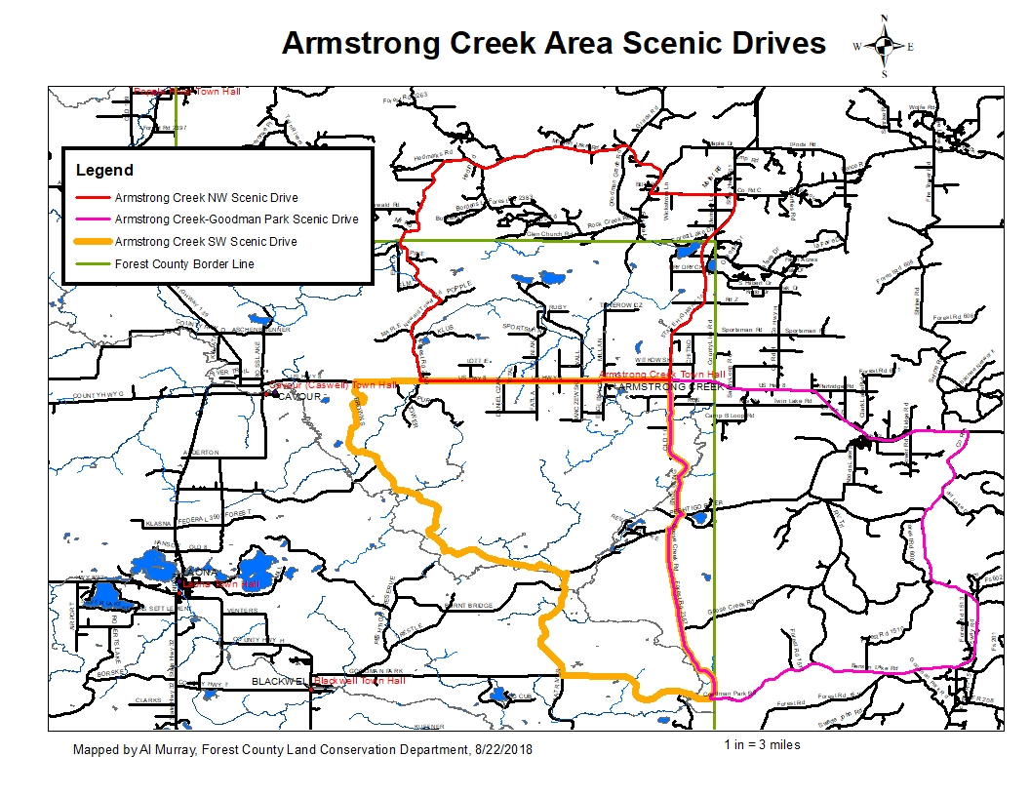

**Armstrong Creek Goodman Park Scenic Drive Directions**

**33 miles, approximately 56 minutes**

Google Maps Link:

<https://drive.google.com/open?id=1xL7Mwctun5KgIjyFU04FRzNAGVHjnZeR&usp=sharing>

1. Starting at the Armstrong Creek Town Hall, 7885 Old 101 Rd.. Armstrong Creek,WI 54103
2. Head south on Old 101 (FR 2371)- 4.53 mi.
3. Turn right (west) onto Peshtigo River Rd. (FR 2131)- 0.615 mi.
4. Turn left (south) onto Goose Creek Rd.(FR 2367)- 5.72 mi
5. Turn left (east) onto Goodman Park Rd.(FR 2136)- 6.20 mi
6. Turn left (north) onto Parkway Rd.- 8.80 mi
7. Turn left (west) onto US-8- 7.62 mi
8. Turn left (south) onto Old 101 Rd.- 285 ft to the beginning

**DISCLAIMER: PORTIONS OF THIS ROUTE IS GRAVEL ROAD AND SHOULD NOT BE TRAVELED IN WET OR INCLEMENT WEATHER, TRAVELER ASSUMES ALL LIABILITY FOR VEHICLE CAPABILITY AND LIMITATIONS**

**Armstrong Creek Northwest Scenic Drive Directions**

**27 miles, approximately 1 hour**

Google Maps Link:

<https://drive.google.com/open?id=1xL7Mwctun5KgIjyFU04FRzNAGVHjnZeR&usp=sharing>

1. Starting at the Armstrong Creek Town Hall, 7885 Old 101 Rd.. Armstrong Creek,WI 54103
2. Head north on Old 101 (FR 2371)- 285 ft
3. Continue straight (north) on W-101 (FR 2371)- 6.4 mi.
4. Turn left (west) on County C toward Memory Ln.- 0.43 mi.
5. Continue straight (west) onto Morgan Lake Rd.(FR 2359)- 1.44 mi
6. Stay right (north) to stay on Morgan Lake Rd.(FR 2359)- 0.423 mi
7. Turn left (northwest) to stay on Morgan Lake Rd.(FR 2359)- 5.53 mi
8. Turn lright (southwest) onto Newald Tower Rd.(FR 2159) – 10.35 mi
9. Turn left (east) onto US-8- 5.65 mi
10. Turn right (south) onto Old 101 Rd.- 285 ft to the beginning

**DISCLAIMER: PORTIONS OF THIS ROUTE IS GRAVEL ROAD AND SHOULD NOT BE TRAVELED IN WET OR INCLEMENT WEATHER, TRAVELER ASSUMES ALL LIABILITY FOR VEHICLE CAPABILITY AND LIMITATIONS**

**Armstrong Creek Southwest Scenic Drive Directions**

**36 miles, approximately 1 hour, 11 minutes**

Google Maps Link:

<https://drive.google.com/open?id=1xL7Mwctun5KgIjyFU04FRzNAGVHjnZeR&usp=sharing>

1. Starting at the Armstrong Creek Town Hall, 7885 Old 101 Rd.. Armstrong Creek,WI 54103
2. Head south on Old 101 (FR 2371)- 4.53 mi.
3. Turn right (west) onto Peshtigo River Rd. (FR 2131)- 0.615 mi.
4. Turn left (south) onto Goose Creek Rd.(FR 2367)- 5.72 mi
5. Turn right (west) onto Goodman Park Rd.(FR 2136)- 4.01 mi
6. Turn right (north) onto Michigan Creek Rd.(FR 2700)- 6.80 mi
7. Turn left (west) onto Peshtigo River Rd.(FR 2131) – 6.80 mi
8. Turn slight right (north) onto Brown’s Rd. (FR 2132) – 3.54mi
9. Turn right (east) onto US-8- 7.03 mi
10. Turn right (south) onto Old 101 Rd.- 285 ft to the beginning

**DISCLAIMER: PORTIONS OF THIS ROUTE IS GRAVEL ROAD AND SHOULD NOT BE TRAVELED IN WET OR INCLEMENT WEATHER, TRAVELER ASSUMES ALL LIABILITY FOR VEHICLE CAPABILITY AND LIMITATIONS**