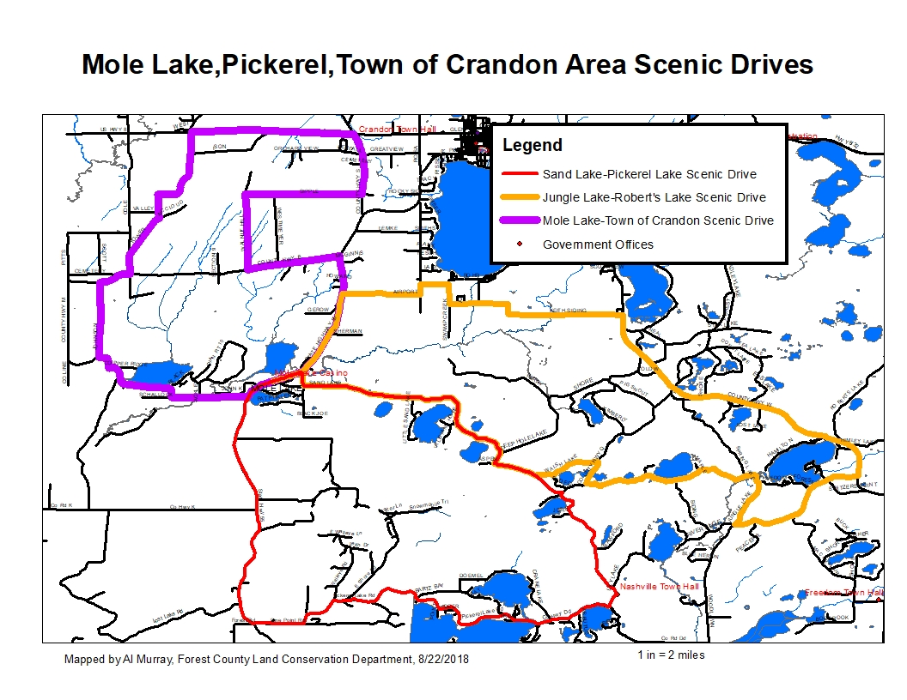

**JUNGLE LAKE-ROBERT’S LAKE SCENIC DRIVE DIRECTIONS**

30 miles, Approximately 51 minutes

Google Maps Link:

<https://drive.google.com/open?id=1xt8Q8y8sjQSeO1Motrd38TQHSFcVst1s&usp=sharing>

1. Beginning at the Mole Lake Casino and Lodge, 3844 WI-55, Cradon, WI 545210
2. Head northeast on WI-55 toward Crandon- 0.595 mi
3. Turn right (east) on Sand Lake Rd.- 0.339 mi
4. stay left on to stay on Sand Lake Rd. .- 5.46 mi
5. Turn left (northeast) on Walsh Lake Rd.- 1.19 mi
6. Turn right (south) on County Q- 0.559 mi
7. Turn left (east) on Jungle Lake Rd.- 3.21 mi
8. Turn left (east) on Woodlawn Rd.- 1.17 mi
9. Turn left (northeast) onto MacArthur Trail.- 1.58 mi
10. Turn left (northwest) on County W toward Crandon- 6.28 mi
11. Turn left (west) on Keith Siding Rd.- 4.166 mi
12. Turn left (south) on Airport Rd.- 1.59mi
13. Turn left (south) on WI-55 toward Mole Lake- 2.60 mi to the beginning

**DISCLAIMER: PORTIONS OF THIS ROUTE IS GRAVEL ROAD AND SHOULD NOT BE TRAVELED IN WET OR INCLEMENT WEATHER, TRAVELER ASSUMES ALL LIABILITY FOR VEHICLE CAPABILITY AND LIMITATIONS**

**SAND LAKE-PICKEREL LAKE SCENIC DRIVE DIRECTIONS**

24 miles, Approximately 38 minutes

Google Maps Link:

<https://drive.google.com/open?id=1xt8Q8y8sjQSeO1Motrd38TQHSFcVst1s&usp=sharing>

1. Beginning at the Mole Lake Casino and Lodge, 3844 WI-55, Cradon, WI 545210
2. Head northeast on WI-55 toward Crandon- 0.595 mi
3. Turn right (east) on Sand Lake Rd.- 0.339 mi
4. stay left on to stay on Sand Lake Rd. .- 6.11 mi
5. Turn right (south) on County Q- 3.25 mi
6. Turn right (northwest) on County DD- 1.37 mi
7. Turn right (northwest) on Pickerel Lake Rd.- 5.37 mi
8. Turn right onto Pine Point Rd.- 0.847 mi
9. Turn right (northwest) on WI-55 toward Crandon- 6.31 mi to the beginning

**MOLE LAKE-TOWN OF CRANDON SCENIC DRIVE DIRECTIONS**

23 miles, Approximately 40 minutes

Google Maps Link:

<https://drive.google.com/open?id=1xt8Q8y8sjQSeO1Motrd38TQHSFcVst1s&usp=sharing>

1. Beginning at the Mole Lake Casino and Lodge, 3844 WI-55, Cradon, WI 545210
2. Head south on WI-55- 0.516 mi
3. Turn right (west) on County M.- 3.25 mi
4. Turn right (north) on Johnson Rd.- 1.83 mi
5. Turn right (east) on County B.- 0.559 mi
6. Turn left (north) on Cole Rd- 0.445 mi
7. Turn slight right (northeast) on Tower Rd.- 3.49 mi
8. Turn right (east) on US Hwy 8 toward Crandon.- 2.76 mi
9. Turn right (south) onto County S.- 1.49 mi
10. Turn right (west) onto Sipple Rd.- 1.98 mi
11. Turn left (south) onto Walnuyt Hill Rd.- 1.82 mi
12. Turn left (east) onto County B.- 1.61mi
13. Turn right (south) on WI-55 toward Mole Lake- 3.58 mi to the beginning

**DISCLAIMER: PORTIONS OF THIS ROUTE IS GRAVEL ROAD AND SHOULD NOT BE TRAVELED IN WET OR INCLEMENT WEATHER, TRAVELER ASSUMES ALL LIABILITY FOR VEHICLE CAPABILITY AND LIMITATIONS**