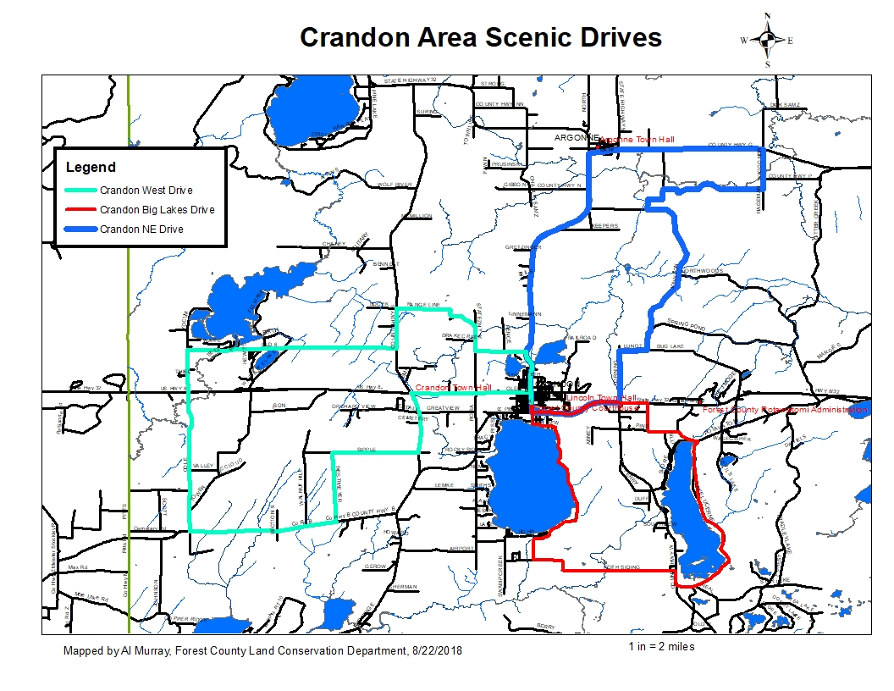

**Crandon NE Scenic Drive Directions**

Google Maps Link:

<https://drive.google.com/open?id=18mlQ1MJRfDy_zd-q1GnowD80NVVy-xSw&usp=sharing>

1. Starting at the Forest County Courthouse
2. Head south on S Lake Ave toward E Polk St- 1,237 ft
3. Turn left onto E Pioneer St, Hwy 8&32 toward Laona- 1.62 mi
4. Turn left (north) on Corning Rd- 0.754 mi
5. Turn right onto Lundt Rd- 0.471 mi
6. Turn left (north) on Johnson Rd stay left at Spring Pond Rd- 4.10 mi
7. Turn right onto Co Hwy P, stay right at first intersection- 0.473 mi
8. Co Hwy P turns slightly left and becomes Peshtigo River Rd- 1,312 ft
9. Turn right onto Co Rd P- 0.688 mi
10. Head east (right) on Co Rd P toward Hageman Rd- 1.47 mi
11. Continue straight onto Waggoner Rd- 0.726 mi
12. Turn left (west) on Co Hwy G/Co Rd G toward Argonne Continue to follow Co Hwy G- 3.01 mi
13. Turn left onto WI-32 S/WI-55 S- 6.61 mi to the beginning

**DISCLAIMER: PORTIONS OF THIS ROUTE IS GRAVEL ROAD AND SHOULD NOT BE TRAVELED IN WET OR INCLEMENT WEATHER, TRAVELER ASSUMES ALL LIABILITY FOR VEHICLE CAPABILITY AND LIMITATIONS**

**Crandon West Scenic Drive Directions**

Google Maps Link:

<https://drive.google.com/open?id=18mlQ1MJRfDy_zd-q1GnowD80NVVy-xSw&usp=sharing>

1. Starting at the Forest County Courthouse
2. Turn Right (north) on S Lake Ave toward W Madison St-0.254 mi
3. Continue straight onto N Lake Ave- 1.03 mi
4. Turn Right (west) on Range Line Rd-0.878 mi
5. Turn Right (north) on Town Line Rd- 0.626 mi
6. Turn left onto Range Line Rd- 1.58 mi
7. Turn left (south) on County Rd S-0.979 mi
8. Turn right onto Old Hwy 8 Rd-3.60 mi
9. Turn left (south) on Old 8 Rd toward Highway 8- 1.02 mi
10. Continue straight across Highway 8 onto Cole Rd- 3.44 mi
11. Turn Left (east) on Co Hwy B/Co Rd B toward Kramer Ln- 2.55 mi
12. Turn left onto Westimeyer Rd- 1.71 mi
13. Turn right (east) on Sipple Ln toward County Rd S- 1.48 mi
14. Turn left onto County Rd S to stop sign-1.49 mi
15. Turn right (east) on US-8 E toward Crandon-2.07 mi
16. Turn right onto N Lake Ave-0.254 mi to the beginning

**DISCLAIMER: PORTIONS OF THIS ROUTE IS GRAVEL ROAD AND SHOULD NOT BE TRAVELED IN WET OR INCLEMENT WEATHER, TRAVELER ASSUMES ALL LIABILITY FOR VEHICLE CAPABILITY AND LIMITATIONS**

**Crandon Big Lakes Scenic Drive Directions**

Google Maps Link:

<https://drive.google.com/open?id=18mlQ1MJRfDy_zd-q1GnowD80NVVy-xSw&usp=sharing>

1. Starting at the Forest County Courthouse
2. Head south on S Lake Ave toward E Polk Head south on S Lake Ave toward E Polk St-1,237 ft
3. Turn left onto US-8 E/E Pioneer StContinue to follow US-8 E-2.11 mi
4. Turn right (south) on Bear Rd-1,070 ft
5. Continue straight-174 ft
6. Merge onto Potawatomi Trail to the left- 1.41 mi
7. Turn right onto Lake Lucerne Dr- 4.37 mi
8. Turn right onto County Rd W- 0.329 mi
9. Turn left onto Keith Siding Rd-2.69 mi
10. Turn Right-(north) on County Park Rd toward E Lakeview St-0.511 mi
11. Turn right onto E Lakeview St-0.400 mi
12. Turn right to stay on E Lakeview St, County Park is straight ahead- 3.09 mi
13. Stay straight (west) on E Lakeview St toward S Park Ave- 0.262 mi
14. E Lakeview St turns right and becomes S Lake Ave-0.283 mi to stop sign
15. Go straight on S Lake Ave -0.250 mi to the beginning

**DISCLAIMER: PORTIONS OF THIS ROUTE IS GRAVEL ROAD AND SHOULD NOT BE TRAVELED IN WET OR INCLEMENT WEATHER, TRAVELER ASSUMES ALL LIABILITY FOR VEHICLE CAPABILITY AND LIMITATIONS**