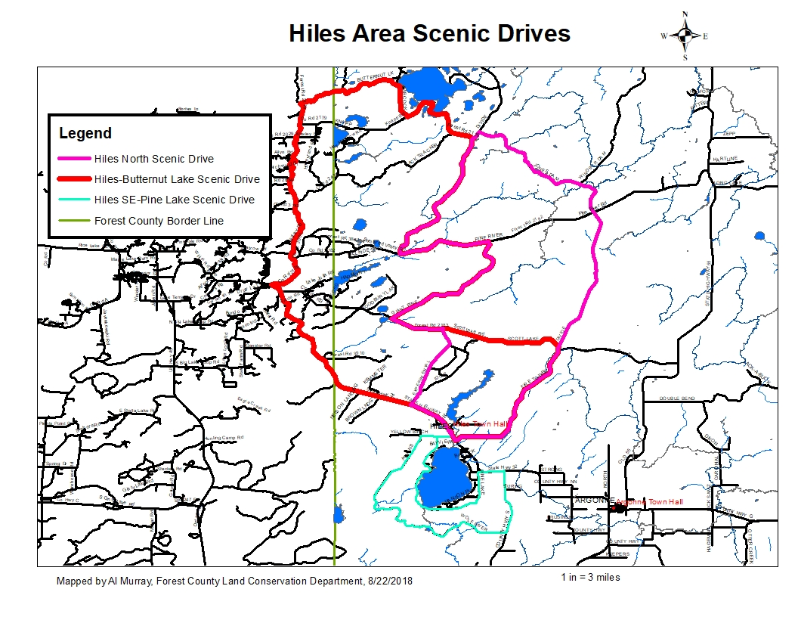

**Hiles-Butternut Lake Scenic Drive**

19.1 miles, Approximately 32 minutes

Google Maps Link:

<https://drive.google.com/open?id=1lkkwMLiSQpTTOUPBp7zDmwfxmGtjxnN4&usp=sharing>

1. Starting at the Hiles Town Hall, 9190 N. Main Street, Hiles,WI 54511
2. Head south on N Main St toward WI-32 N- 653 ft
3. Turn right onto WI-32 N- 8.98 mi
4. Turn right onto Military Rd (FR 2178)- 4.07 mi
5. Keep left to continue on Old Military Rd (FR 2207)- 2.03 mi
6. Turn left onto Military Rd (FR 2178) - 2.53 mi
7. Turn right onto Butternut Lake Rd (FR 2183)-1.40 mi
8. Stay right (east) on Butternut Lake Rd (FR 2183)- 1.76 mi
9. Turn right onto Babcock Rd-1.35 mi
10. Turn left to stay on Babcock Rd- 0.338 mi
11. Turn left (northeast) on Knapp Rd(FR 2179) - 1.01 mi
12. Turn right to stay on Knapp Rd(FR 2179) - 2.38 mi
13. Turn right (southwest) on Divide Rd(FR 2176) - 5.63 mi
14. Turn left onto Pine River Rd (FR 2182)- 2.76 mi
15. Turn right onto Giant Pine Rd(FR 2414) - 5.00 mi
16. Turn left onto Scott Lake Rd(FR 2183)- 1.60 mi
17. Stay straight (east) on Scott Lake Rd (FR 2183)- 3.69 mi
18. Turn Right (south) on Fire Tower Rd (FR 2174)-5.39 mi
19. Turn right onto WI-32 N-0.270 mi
20. Slight right onto N Main St-748 ft to the point of beginning

**DISCLAIMER: PORTIONS OF THIS ROUTE IS GRAVEL ROAD AND SHOULD NOT BE TRAVELED IN WET OR INCLEMENT WEATHER, TRAVELER ASSUMES ALL LIABILITY FOR VEHICLE CAPABILITY AND LIMITATIONS**

**Hiles North Scenic Drive**

38 miles, Approximately 1 hour, 39 minutes

Google Maps Link:

<https://drive.google.com/open?id=1lkkwMLiSQpTTOUPBp7zDmwfxmGtjxnN4&usp=sharing>

1. Starting at the Hiles Town Hall, 9190 N. Main Street, Hiles,WI 54511
2. Head south on N Main St toward WI-32 N- 653 ft
3. Turn right onto WI-32 N- 1.73 mi
4. Turn right (northeast) onto Experimental Rd. (FR 2414)- 3.44 mi
5. Turn left onto Scott Lake Rd (FR 2183)- 1.60 mi
6. Turn Right (northeast) on Giant Pine Rd (FR 414) toward Pine River Rd-5.00 mi
7. Turn left onto Pine River Rd (FR 2182)- 2.76 mi
8. Turn right onto Divide Rd (FR 2176)- 5.63 mi
9. Stay Right (northeast) on Divide Rd (FR 2176)- 0.327 mi
10. Turn right onto Jones Dam Rd (FR 2177)- 4.27 mi
11. Stay Right (southeast) on Divide Rd (FR 2174)-7.37 mi stay on FR 2174- straight
12. Stay straight (south) on Forest Rd 2174/Continue to follow Forest Rd 2174- 5.64 mi
13. Turn right onto WI-32 N- 0.270 mi
14. Slight right onto N Main St-748 ft to the point of beginning

**DISCLAIMER: PORTIONS OF THIS ROUTE IS GRAVEL ROAD AND SHOULD NOT BE TRAVELED IN WET OR INCLEMENT WEATHER, TRAVELER ASSUMES ALL LIABILITY FOR VEHICLE CAPABILITY AND LIMITATIONS**

**DISCLAIMER: PORTIONS OF THIS ROUTE IS GRAVEL ROAD AND SHOULD NOT BE TRAVELED IN WET OR INCLEMENT WEATHER, TRAVELER ASSUMES ALL LIABILITY FOR VEHICLE CAPABILITY AND LIMITATIONS**

**Hiles SE Scenic Drive**

20 miles, Approximately 44 minutes

Google Maps Link:

<https://drive.google.com/open?id=1lkkwMLiSQpTTOUPBp7zDmwfxmGtjxnN4&usp=sharing>

1. Starting at the Hiles Town Hall, 9190 N. Main Street, Hiles,WI 54511
2. Head south on N Main St toward WI-32 N- 0.25 mi
3. Turn right onto W Pine Lake Rd- 0.398 mi
4. Stay Straight (west) on Yellow Birch Rd. - 0.493 mi
5. Turn left (south) on Atkins Road. – 3.07 mi
6. Stay left (southeast on Wolf River Rd (FR 2861) – 5.77 mi
7. Turn left (north) on County S– 2.61 mi
8. Turn left (west) on WI 32- 0.648 mi
9. Turn left (west) on Mitchell Plot Rd- 653 ft.
10. Turn left (south) on E. Pine Lake Rd. -2.99 mi
11. Stay right(northwest) on W. Pine Lake Rd. -3.35 mi
12. Turn right(east) to stay on W. Pine Lake Rd. -0.398 mi
13. Turn left on S Main St toward WI-32 N- 0.25 mi to the point of beginning

**DISCLAIMER: PORTIONS OF THIS ROUTE IS GRAVEL ROAD AND SHOULD NOT BE TRAVELED IN WET OR INCLEMENT WEATHER, TRAVELER ASSUMES ALL LIABILITY FOR VEHICLE CAPABILITY AND LIMITATIONS**