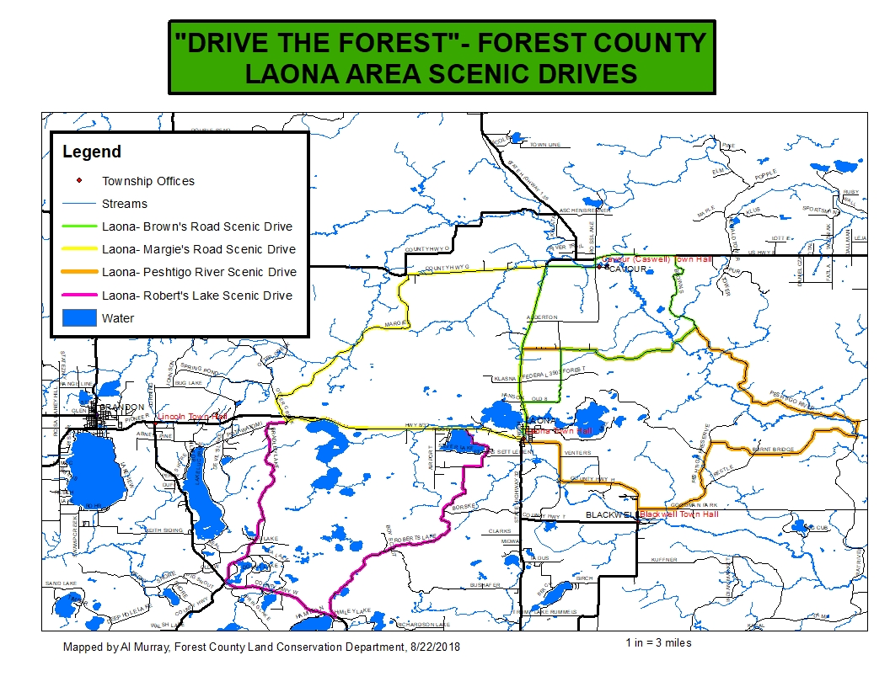

**LAONA- ROBERT’S LAKE AREA SCENIC DRIVE DIRECTIONS**

29 miles, Approximately 26 minutes

Google Maps Link:

<https://drive.google.com/open?id=1JB493oSCQ-A_LMe2T6aDTdnXNrBxtP-n&usp=sharing>

1. Beginning at the Laona Town Hall, 5146 Linden St, Laona, WI 54541
2. Turn left (west) on US-8 W toward Crandon- 1.58 mi
3. Turn left (south) on E Silver Lake Rd- stay straight on three intersections, continue onto Starks Settlement Rd - 2.28 mi
4. Turn left (south) on Roberts Lake Rd, stay straight- 6.01 mi
5. Turn Right (northwest) on County Rd W toward Crandon- 3.31 mi
6. Turn right (northeast) on Bradley Lake Rd toward Horseshoe Lake Rd- 2.75 mi
7. Stay straight on 3 intersections.
8. Turn left (north) on Bradley Lake Rd- 2.66 mi
9. Turn right on Fire Tower Road - 1.17 mi
10. Turn right (northeast) on Potawatomi Trail – 1.52 mi to the intersection with US Hwy 8
11. Turn right (east) on US-8 E toward Laona- 5.39 mi to the beginning

**DISCLAIMER: PORTIONS OF THIS ROUTE IS GRAVEL ROAD AND SHOULD NOT BE TRAVELED IN WET OR INCLEMENT WEATHER, TRAVELER ASSUMES ALL LIABILITY FOR VEHICLE CAPABILITY AND LIMITATIONS**

**LAONA- PESHTIGO RIVER ROAD SCENIC DRIVE DIRECTIONS**

30 miles, Approximately 1 hour, 3 minutes

Google Maps Link:

<https://drive.google.com/open?id=1JB493oSCQ-A_LMe2T6aDTdnXNrBxtP-n&usp=sharing>

1. Beginning at the Laona Town Hall, 5146 Linden St, Laona, WI 54541
2. Head north on US-8 W- 0.436 mi
3. Turn left to stay on US-8 E-3.00 mi
4. Turn right (east) on Peshtigo River Rd- 5.28 mi
5. Turn right (southeast) at intersection with Brown’s-6.86 mi
6. Turn right (south) on Michigan Creek Rd toward Burnt Bridge Rd- 0.600 mi
7. Turn right (northwest) on Burnt Bridge Rd toward Trestle Rd- 4.66 mi
8. Stay straight at Trestle Rd. Intersection
9. Turn left (south) on Peshtigo Preserve Rd- 6.15 mi
10. Turn right (west) on Goodman Park Rd toward Co Hwy H- 0.998 mi
11. Turn right onto Co Hwy H towards Laona- 5.03 mi
12. Turn right onto Linden St- 656 ft to the beginning

**DISCLAIMER: PORTIONS OF THIS ROUTE IS GRAVEL ROAD AND SHOULD NOT BE TRAVELED IN WET OR INCLEMENT WEATHER, TRAVELER ASSUMES ALL LIABILITY FOR VEHICLE CAPABILITY AND LIMITATIONS**

**LAONA- MARGIE’S ROAD SCENIC DRIVE DIRECTIONS**

24 miles, Approximately 40 minutes

Google Maps Link:

<https://drive.google.com/open?id=1JB493oSCQ-A_LMe2T6aDTdnXNrBxtP-n&usp=sharing>

1. Beginning at the Laona Town Hall, 5146 Linden St, Laona, WI 54541
2. Head west on US-8 W toward Crandon- 5.39 mi
3. Turn left (southwest) on Potawatomi Trail- 0.986 mi
4. Turn right(north) on Otter Creek Rd toward US-8- straight across US 8- 0.880 mi
5. Turn right (northeast) on Margies Rd-7.09 mi to stop sign
6. Turn right (east) on Co Hwy G toward Cavour- 3.59 mi
7. Turn right (south)on US-8 toward Laona- 6.55 mi follow US 8 through town to the beginning

**DISCLAIMER: PORTIONS OF THIS ROUTE IS GRAVEL ROAD AND SHOULD NOT BE TRAVELED IN WET OR INCLEMENT WEATHER, TRAVELER ASSUMES ALL LIABILITY FOR VEHICLE CAPABILITY AND LIMITATIONS**

**LAONA- BROWN’S ROAD SCENIC DRIVE DIRECTIONS**

22 miles, Approximately 48 minutes

Google Maps Link:

<https://drive.google.com/open?id=1JB493oSCQ-A_LMe2T6aDTdnXNrBxtP-n&usp=sharing>

1. Beginning at the Laona Town Hall, 5146 Linden St, Laona, WI 54541
2. Head north on US-8 W- 0.436 mi
3. Turn left to stay on US-8 E-1.00mi
4. Turn right (east) on Old 8 Rd- 3.42 mi
5. Turn right(east) at Peshtigo River Rd- 4.34 mi
6. Turn left (north) at intersection with Brown’s-3.48 mi
7. Turn left (west) on US-8 W toward Laona- 2.11 mi
8. Turn left (south) on Co Hwy G toward Cavour, stay straight after river—3.31 mi
9. Turn left (south) on US-8 W toward Laona- 4.47 mi follow US 8 through town to the beginning

**DISCLAIMER: PORTIONS OF THIS ROUTE IS GRAVEL ROAD AND SHOULD NOT BE TRAVELED IN WET OR INCLEMENT WEATHER, TRAVELER ASSUMES ALL LIABILITY FOR VEHICLE CAPABILITY AND LIMITATIONS**