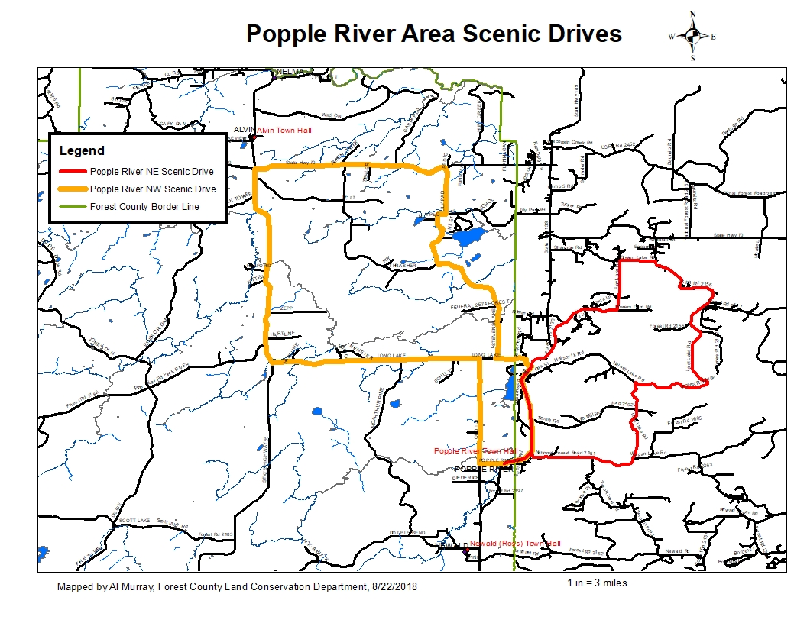

**Popple River NE Scenic Drive**

29 miles, Approximately 57 minutes

Google Maps Link:

<https://drive.google.com/open?id=1MGjRUCIm5ZpNhvp9i_eXUJL6zXVFv3V5&usp=sharing>

1. Beginning at the instersection of WI-139 and Popple River Rd
2. Head north on WI-139 - 5.600 mi
3. Turn right (northeast) on Fay Lake Rd (FR 2133)-3.04 mi
4. Stay left (north) onto Fay Lake Rd (FR 2133)-2.01 mi
5. Turn right (east) on Dream Lake Rd.(FR 2450)-1.03 mi
6. Turn right (south) on Lost Lake Rd (FR 2156)- 7.12 mi.
7. Turn left (south) onto Halsey Lake Road – 5.62 mi
8. Stay right (west) onto Morgan Lake Road (FR 2161)- 3.33 mi
9. Turn left onto WI-139 S-0.86 mi to the point of beginning

**DISCLAIMER: PORTIONS OF THIS ROUTE IS GRAVEL ROAD AND SHOULD NOT BE TRAVELED IN WET OR INCLEMENT WEATHER, TRAVELER ASSUMES ALL LIABILITY FOR VEHICLE CAPABILITY AND LIMITATIONS**

**Popple River NW Scenic Drive**

40 miles, Approximately 1 hour, 7 minutes

Google Maps Link:

<https://drive.google.com/open?id=1MGjRUCIm5ZpNhvp9i_eXUJL6zXVFv3V5&usp=sharing>

1. Beginning at the instersection of WI-139 and Popple River Rd
2. Head west on Popple River Rd- 0.700 mi
3. Turn right (north) on Old Hwy 139 Rd-4.30 mi
4. Turn left (west) onto Long Lake Road (FR 2167)- 5.96 mi
5. Trun right (north) on WIU-55 N-8.20 mi
6. Turn right (east) on WI-70 E- 5.60 mi.
7. Turn right (south) onto Lily Pad Road – 1.92 mi
8. Turn right (west) onto Stevens Lake Road (FR 2169) which turns back to Lily Pad Rd- 4.44 mi
9. Turn left (south) onto Stevens Lake Road (FR 2169) which turns back to Lily Pad Rd- 4.99 mi
10. Turn left on Long Lake Rd-1.25 mi
11. Turn right onto WI-139 S-4.56 mi to the point of beginning

**DISCLAIMER: PORTIONS OF THIS ROUTE IS GRAVEL ROAD AND SHOULD NOT BE TRAVELED IN WET OR INCLEMENT WEATHER, TRAVELER ASSUMES ALL LIABILITY FOR VEHICLE CAPABILITY AND LIMITATIONS**